Breaking the Cycle: Supporting the campaign
Join our campaign to move beyond crisis to a country free from homelessness

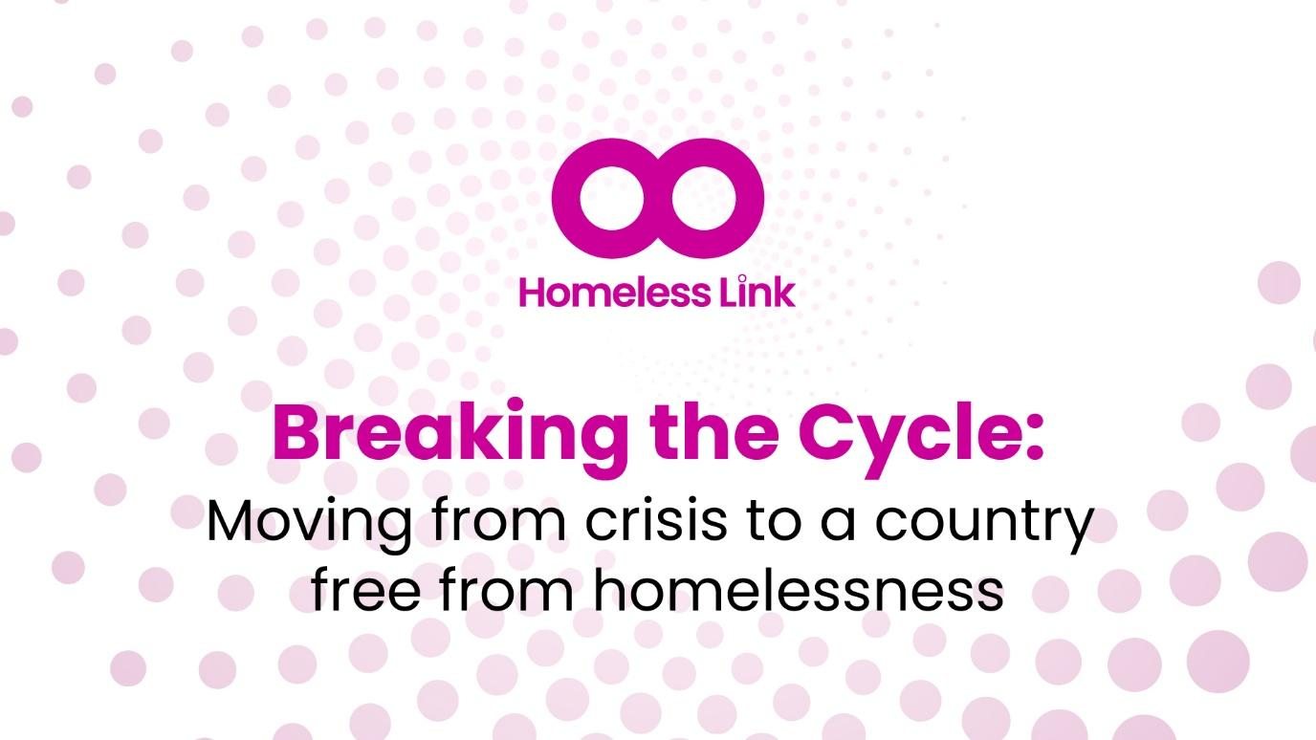

Contents

What is the Breaking the Cycle campaign?

Getting local MPs involved

Template letter to your MP

Tips for a successful MP visit

Template press release

Template social media posts

Social media Breaking the Cycle campaign graphics

Quick links: Key ways you can get involved

Use our template letters to write to your local MP. In your letter you can invite them to visit your service, to have a meeting with them or ask them to write to the Minister asking them to deliver a Homelessness Strategy that supports the work of your service.

Our template social media posts and press release will help you publicise any MP visit or meeting.

You can also show your support on social media using our new social media kit.

We will update these assets as the campaign develops, and you can always find the latest version in the Google Drive folder.

Introduction: What is the Breaking the Cycle campaign?

With more people than ever experiencing homelessness, underfunded and under-resourced support services are struggling to meet the demand. This means more people remaining homelessness for longer, in an ongoing cycle of crisis.

The Government has pledged to introduce a new Homelessness Strategy in the coming months and we are urging them to take this opportunity to break the cycle.

What we’re calling for is both an emergency response to spiraling rates of homelessness, and an ambitious, resourced plan to transform homelessness support within a decade.

Fortunately, these are two sides of the same coin. And by delivering both, a new strategy can set us on the path to a country free from homelessness.

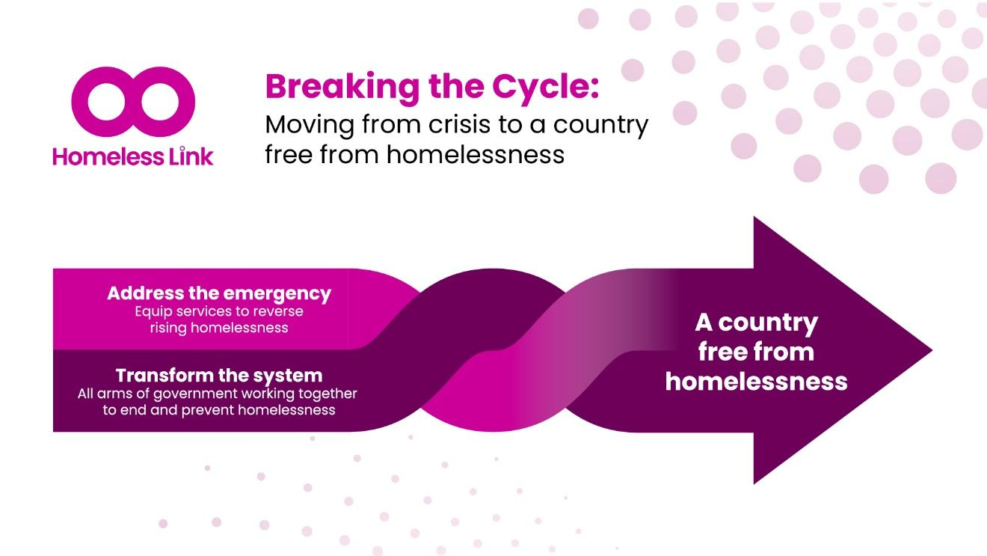

Ending the crisis of dwindling resource and soaring demand will empower homelessness services to focus on delivering support that works in the long term. Many of these solutions have already proven their effectiveness, such as specialist supported housing and Housing First.

To build a country without homelessness, we need all arms of Government working together. Too often efforts to reduce homelessness have been undermined by policy decisions across Departments which are not formally responsible for homelessness. For example, the Home Office’s decision to reduce the asylum accommodation move-on period or the Treasury’s decision to freeze Local Housing Allowance rates.

We’re calling for the new Homelessness Strategy to set out how all levels of government will be accountable for reducing and preventing homelessness.

See our latest Breaking the Cycle briefing for all the details. A short two-page summary, perfect for sharing with MPs, is also available on our website.

Our four-point plan for change

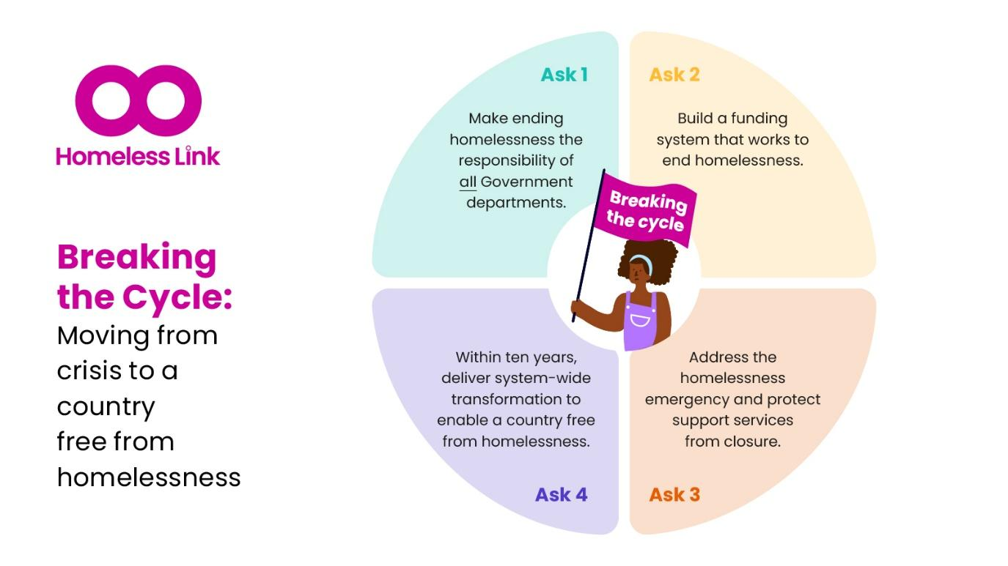

Our Breaking the Cycle campaign outlines a four-point plan to end the emergency and get back on track to ending homelessness.

We have graphics illustrating that plan, including the one above, in our Social Media Pack, which also includes suggested copy for posting on your channels.

How you can help shape the Homelessness Strategy

Campaigning has already helped shape cross-government initiatives like the Comprehensive Spending Review. Now there is a chance to speak up and make sure the new Homelessness Strategy includes everything it needs to address record levels of homelessness and set us on a path to a country free from homelessness.

As the strategy is developed, the government will be listening closely to what MPs are saying about homelessness in their area. We need to make sure they hear from local services about the issues you are facing and what needs to change.

That means this is the perfect time to get your MP speaking up about the importance of the vital work you do for your community.

Reaching out takes just a few minutes with our MP template letters and guidance on speaking with politicians. But it really can make a difference convincing your MP to champion homelessness services in Parliament and in your community.

Frontline homelessness services based in their local community have extremely high levels of support amongst the public and politicians. MPs want to hear about solutions to rising levels of homelessness, and your service is part of that solution.

How to get started
Write to your MP and ask them to back the campaign

There are two actions you can ask your MP to take to support the Breaking the Cycle campaign, which are included in our template letter below. Ask your MP to:

- Visit your services to better understand local homelessness issues, and how – with an effective Homelessness Strategy– you can play an even stronger role in ‘Breaking the Cycle’ of homelessness in your area.

- Write a letter to the Secretary of State for Housing, Communities and Local Government asking them to ensure the upcoming Homelessness Strategy includes support measures to support services like yours. The content of this letter to the Minister can be guided by our Breaking the Cycle briefing, or you can craft it with your MP to reflect the local situation. You can also pass on our contact details to your MP if they’d like further information – please ask them to email Stefan.donnelly@homelesslink.org.uk

If you are able to secure a visit, we will be able to provide you with a Breaking the Cycle campaign placard to create a photo opportunity with your MP. Just let us know when your visit is taking place and we will arrange delivery – email stefan.donnelly@homelesslink.org.uk.

Visits to services can really help push homelessness to the top of MPs' priorities lists. But we appreciate this may not always be possible, and if you can’t currently support a visit you can remove that section from our template letter and perhaps ask for a meeting instead – either in person or online.

In fact please do customise our template letter as much as you like to include local issues, concerns and priorities. Please also add your own organisation’s name and branding, as MPs tend to respond much better to locally-raised issues.

MP template letter

Please find below links to download template letters to your MP about the funding issues raised in our Breaking the Cycle campaign. We will regularly update the copy in these letters to reflect any new developments or opportunities for your MP to get involved in campaigning.

Your template letter to your MP

When you are ready to contact your MP, you can find their contact details on Parliament’s website.

Meeting your MP

Tips on hosting a successful MP visit

“Involving service users in visits with your local MP provides a first-hand understanding of the issues that need addressing. Service users can help ensure that the concerns and needs of the community are accurately represented and prioritized, leading to more effective advocacy and policy changes.”

Fiona Pugh from Homeless Link member SPEAR shares her top tip from a recent successful MP visit.

MPs are typically very keen to meet with people providing important local services to their constituents, and learn more about how they can help deliver positive change.

So invitations to visit will generally be enthusiastically received by MPs, even if it takes some time to arrange due to an MPs busy diary.

Below we’ve put together a few top tips for a successful MP meeting

#1: Prepare key points to share

Prioritise a few key messages you want your MP to hear during your meeting. With lots to say about the state of homelessness nationally and locally, focusing in on one or two important points you want your MP to understand can help focus and guide your discussion.

In the context of the Breaking the Cycle campaign, this could be something like: ‘If services like ours received the right funding, we could save local and national government money by preventing homelessness rising further.’

More broadly, points to consider sharing with your MP could include:

- How your organisation is currently funded and any challenges that brings
- How a more longer-term and more predictable funding system would benefit your work
- What you would like to do if you had the funding support
- How the current funding system holds your organisation back

#2: Be confident in speaking about your priorities

The MP is visiting you because they want to learn about your service. And you will definitely know more about your service and local homelessness issues than they do, so you should feel confident in telling them about the issues you encounter every day.

Try and keep the conversation grounded in your experience providing homelessness support and prevention services, and the challenges the current system poses. This will encourage the MP to genuinely listen to and learn from your experience.

#3: Do some quick revision on your MP and the Breaking the Cycle campaign

You don’t need to be an expert in your MP’s personal history or the detail of our Breaking the Cycle report. But having a quick check of your MP’s profile on Parliament’s website will let you know if they have existing interests in this area or if they have an official role with the government or an opposition political party.

Similarly, reviewing our 2-page summary of the Breaking the Cycle report – which you can also share with MPs – will give you a basic understanding of the key points of the campaign. You can find this summary and the full report on our website.

#4: Give them an opportunity to publicise their visit

Your MP will likely want to publicise their visit to show they are doing their bit to support important community services. Supporting them to do this can help your service get publicity and public support too, so it can be a win-win situation.

You can use our template press release (see below) and social media posts to make it as easy as possible for your MP to celebrate the excellent work your service does.

#5: Leave your MP with a tangible action to take

MPs often start or end meetings with a question of ‘so what can I do for you?’

So be clear on the main action you’d like your MP to take from the start. To support the Breaking the Cycle campaign, they can write to relevant Ministers, asking them to ensure support for services like yours is a key part of the upcoming Homelessness Strategy.

If an MP wants more details before doing so, you can encourage them to contact us on stefan.donnelly@homelesslink.org.uk. Our Breaking the Cycle briefing also includes key facts and stats they can raise.

You could also ask them to visit you again next year, so you can update one another on how things have progressed. And of course feel free to ask them to support you with specific local challenges, such as intervening on an issue with the council or supporting better coordination with local health services.

#6: Use any local stats, facts and stories you have

Your MP will be most interested in details about your local area. We can provide a briefing including the latest homelessness stats in your local authority area – just email stefan.donnelly@homelesslink.org.uk.

But please do share any other local insights you have with your MP, and encourage them to share these with colleagues in government.

Tools to support and publicise your MP meeting

Template press release

Adapt our template press release to publicise your MPs visit. Contact your MP’s office to coordinate and agree the content of your press release before sending it out, or you can ask the MP’s office to share with the press.

Social media posts marking a local MPs visit

Your MP is likely to have profiles on one or more of the major social media platforms, including Facebook, LinkedIn, X (Twitter), Instagram and BlueSky.

If you post an image of their visit on your social media channels make sure to tag their official account so they definitely see it and can reshare. You can usually find their official accounts on their profile on Parliament’s website. Please also tag Homeless Link so we can see and support your posts.

To tag on most platforms, insert the @ symbol and then type in your MPs name or user name.

Template social media post copy

Hosting <MP NAME> today – great to share how we’re supporting local people affected by homelessness.

Hoping the new Homelessness Strategy will give us the tools #BreakTheCycle of homelessness locally and nationally. More info on Homeless Link's website

https://homeless.org.uk/what-we-do/campaigning-and-influencing/breaking-the-cycle/

<PHOTOGRAPH OF MP AT YOUR SERVICE, WITH PLACARD>

Share your support on social media

Breaking the Cycle Social Media Graphics

We have also produced a series of new social media graphics to help you shout about your support for the Breaking the Cycle campaign.
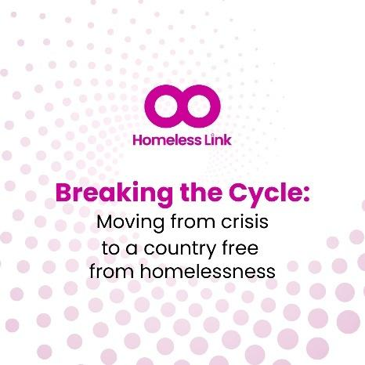

Post these on your organisation’s social media channels, or your personal profile, to show your support.

View and download the different versions of the graphics, designed for all major social media platforms, in our Social Media Campaign Kit.

Let us know how your meeting goes

Understanding the relationships our members have built with MPs across the country really helps and guides our national influencing work. So please email stefan.donnelly@homelesslink.org.uk with a quick summary of how your meeting went, or put in a call with our Campaigns Manager Stefan.

Thank you for getting Involved!

We know everyone working in homelessness services has a lot on their plate, so we really appreciate you taking the time to encourage your MP to get involved in Breaking the Cycle of rising homelessness.

This government has pledged to “get back on track to ending homelessness.” Voices of services like yours will be key in guiding that mission, and holding Ministers to account.

