Outreach Training Programme

Delegate Workbook

Name:

Date:

Who’s in the room?
Speak to fellow delegates and fill in the form:
Category | Name(s)
Experienced in street outreach
New to street outreach
Based in a city
Based in a rural area
Travelled the furthest to get here
Works nearest to here
Has an interesting or unusual skill or talent
Has a birthday in the next 2 weeks

Contact and Support

Background: Rough Sleeping Initiative
This training was developed with funding from the Ministry of Housing, Communities and Local Government (MHCLG) as part of the Rough Sleeping Initiative (RSI) to reduce the number of people sleeping rough in England.

Developed by Homeless Link with contributions from member organisations and people with lived experience of street outreach, the training aims to help outreach teams deliver effective support interventions and achieve positive outcomes for people sleeping rough.

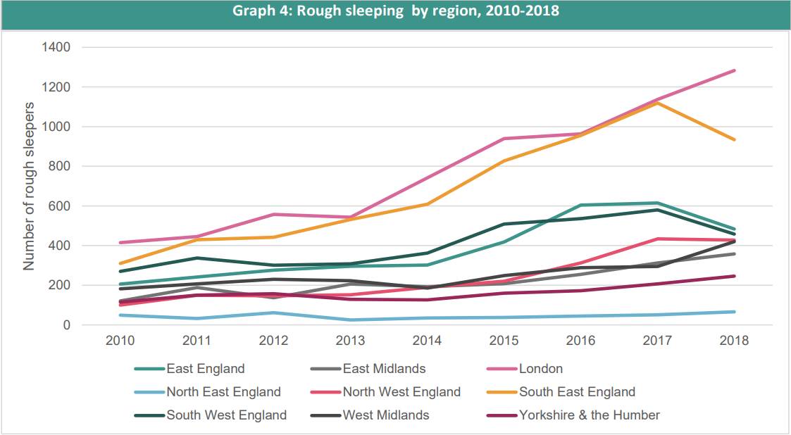

Outreach Shift Checklist:

Risk and Safety

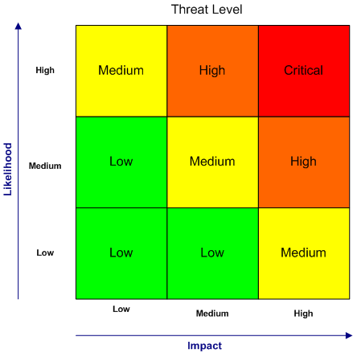

A risk matrix is a matrix that is used during risk assessment to define the level of risk by considering the category of probability or likelihood against the category of consequence severity. This is a simple mechanism to increase visibility of risks and assist decision making.

The risk matrix is the starting point of understanding risk and not the end point. Remember Dynamic Risk Assessing! Each time you should reassess the risk and increase or decrease the input needed depending on the situation.

An example of a LOW risk

An example of a MEDIUM risk

An example of a HIGH risk

An example of a CRITICAL risk

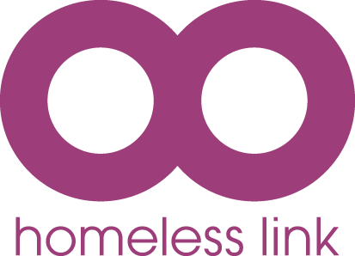
Team risk assessment – shift planning
Let’s end homelessness together
Homeless Link, Minories House, 2-5 Minories, London EC3N 1BJ | 020 7840 4430
www.homeless.org.uk | Twitter: @Homelesslink | Facebook: www.facebook.com/homelesslink
© Homeless Link 2017. All rights reserved. Homeless Link is a charity no. 1089173 and a company no. 04313826.

Risk | What are your concerns? | What actions can reduce this risk? | Who else needs to be involved?
Making first contact with someone sleeping rough who is not known to services
Meeting someone who has a history of aggression
Doing outreach to an encampment of tents
in woodland
Visiting someone who is becoming paranoid about outreach staff trying to control them
Going into an area with no mobile phone reception

Safety planning
Let’s end homelessness together
Homeless Link, Minories House, 2-5 Minories, London EC3N 1BJ | 020 7840 4430
www.homeless.org.uk | Twitter: @Homelesslink | Facebook: www.facebook.com/homelesslink
© Homeless Link 2017. All rights reserved. Homeless Link is a charity no. 1089173 and a company no. 04313826.

This is my safety plan to help keep me safe in the following situation

My warning signs (this can include thoughts of hurting myself or others, despair, hopelessness, intense anger, feeling out of control, feeling threatened, mood changing, drug or alcohol use increasing, and more):

Ways of coping
This is what I will do to take my mind off the crisis when I experience the warning signs:
I will go to these safe places:
(e.g. staff office, GP surgery/A&E, day centres, family/friends home etc)
I will do these activities:
(enjoyable activities, grounding techniques etc)
I will speak to:
(trusted support network, social worker, GP, key worker etc)
I can also: | - Call the Samaritans 08457 90 90 90  - Attend my local A&E department  - Call the emergency services 999

Support planning
Let’s end homelessness together
Homeless Link, Minories House, 2-5 Minories, London EC3N 1BJ | 020 7840 4430
www.homeless.org.uk | Twitter: @Homelesslink | Facebook: www.facebook.com/homelesslink
© Homeless Link 2017. All rights reserved. Homeless Link is a charity no. 1089173 and a company no. 04313826.

What is the goal? | Activities planned & who is taking action | By when? | Who else will help? | What will a positive outcome look like?

Routes off the streets

Support plans need to be:

Specific | Always specific to the individual and not generalised. Try and break down the goals as much as possible.  i.e., someone might want to be ‘drug free’ but is that specific enough? Is it better to say ‘access drug service for support’?
Measurable | You should be able to break them down into small steps and measure the positive steps that are achieved  i.e., if someone wants to be drug free, they could set themselves weekly small reductions in their plan to ensure they are measuring and seeing constant improvement.
Attainable/ Achievable | All goals need to have an end goal, otherwise people get frustrated at not achieving anything  i.e., stating that someone will be drug free in 6 months might not be achievable for someone who has entrenched substance misuse. Instead, you could explore that in 6 months’ time the person is accessing drug services and stable on medication.
Relevant/ Realistic | They have to be relevant to the person at the time and what is in their gift to achieve.  i.e., they might not be able to be a premier league football, but they can join a 5-a-side football team
Time-bound | All goals need to have clear time scales for achievements to be made.  i.e., avoiding writing ‘ongoing’ or vague timescales can mean goals can get lost and stagnate. Plus, clearer timescales allow for people to modify their goals if they feel they may need more time rather than waiting for the goal to not be achieved.

Maslow’s Hierarchy of Needs
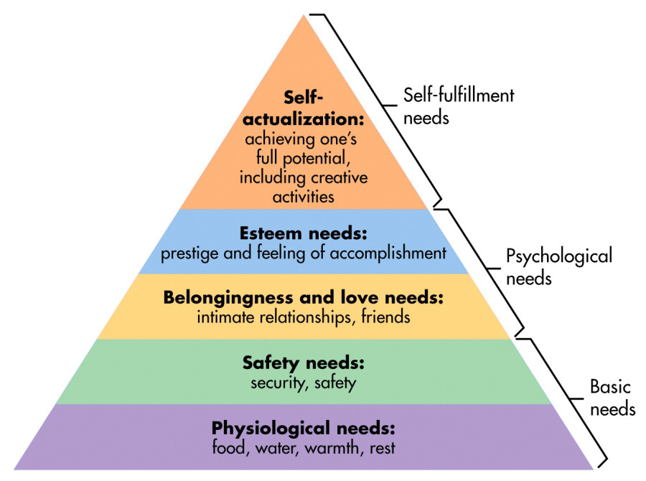

Assertive Outreach
- Rough sleeping puts people at risk
- Moving into appropriate housing is the best option for safety, well-being, recovery
- Where possible, a rapid route off the streets is identified and support offered to access housing/shelter quickly
- Routes off the street are supported by joint working, collaborative case planning
- If someone refuses or if no route is identified, outreach teams are assertive – persistent and positive – in continuing to engage with that person and offer them the right support until they are ready to accept an offer, or until a suitable exit route is found

Diversity and Equality – Equality Act 2010

The 2010 Equality Act stated you cannot be discriminated against due to the following protected characteristics:
- age
- disability
- gender reassignment
- marriage or civil partnership (in employment only)
- pregnancy and maternity
- race
- religion or belief
- sex
- sexual orientation
These factors may also impact on how people have experienced homelessness. Services need to be culturally aware of the above to ensure effective inclusivity.

Study Buddy Reflection – throughout the day, use the following section to note down your learning:

What you have learned? | Thoughts?

Recommended resources
Homeless Link publishes resources for frontline team and managers, including an Outreach Resource Toolkit to accompany this course. Our resources are free to download, and we welcome your ideas for new resources: www.homeless.org.uk/our-work/resources

We also publish a range of short blogs, highlighting emerging issues and developments in practice: www.homeless.org.uk/connect

Legislation
- Care Act 2014: www.legislation.gov.uk/ukpga/2014/23/contents/enacted
- Mental Health Act 2007: www.legislation.gov.uk/ukpga/2007/12/contents
- Mental Capacity Act 2005: www.legislation.gov.uk/ukpga/2005/9/contents
- Equality Act 2010: www.legislation.gov.uk/ukpga/2010/15/contents
- Homelessness Reduction Act 2017: www.legislation.gov.uk/ukpga/2017/13/contents
- Rough Sleeping Strategy 2018: https://assets.publishing.service.gov.uk/government/uploads/system/uploads/attachment_data/file/733421/Rough-Sleeping-Strategy_WEB.pdf
- 2018 New Government initiative to reduce rough sleeping press release: www.gov.uk/government/news/new-government-initiative-to-reduce-rough-sleeping

Toolkits
- Mental Health Service interventions for rough sleepers’ tools and guidance: www.homeless.org.uk/our-work/resources/guidance-on-mental-capacity-act
www.pathway.org.uk/wp-content/uploads/RSTG-2017-FINAL.pdf
- VOICES of Stoke toolkit (using the Care Act as a framework to develop a toolkit that meets the needs of clients who have complex needs): https://www.homeless.org.uk/sites/default/files/site-attachments/VOICES%20Care%20Act%20Toolkit.pdf
- Effective Action: Task and Targeting Toolkit
https://www.homeless.org.uk/our-work/resources/task-and-targeting-toolkit

General tools and information:
- Resources & Worksheets (useful for goal setting and engagement): www.psychologytools.com/
- Transactional Model of Communication (includes free downloadable resources): www.businesstopia.net/communication/transactional-model-communication
- Power & Communication: http://learntech.uwe.ac.uk/communicationskills/Default.aspx?pageid=1379
- Solution Focused Practice and Tools: http://blog.ebta.nu/the-solution-focused-modell
- The Change Model: https://c.ymcdn.com/sites/www.odnetwork.org/resource/resmgr/ODP_46_3/vol46no3-cady_jacobs_koller_.pdf#
- The Stages of Change www.verywellmind.com/the-stages-of-change-2794868
- Motivational Interviewing (videos, resources, background and tools): https://motivationalinterviewing.org/
- Hard Edges 2015 (mapping disadvantage that highlights how embedded trauma is in homelessness): https://lankellychase.org.uk/wp-content/uploads/2015/07/Hard-Edges-Mapping-SMD-2015.pdf
- SAMHSA (America’s Substance Misuse and Mental Health Services Administration. They have taken the lead on many trauma informed responses):
www.samhsa.gov/nctic/trauma-interventions

Films

Invisible People website: https://invisiblepeople.tv/

Housing First England
Thomas’ story.
https://hfe.homeless.org.uk/case-study/thomas%E2%80%99-story
Wayne’s story, describing importance of front door and housing, and its relation to self-esteem.
https://hfe.homeless.org.uk/waynes-story

Real Safeguarding Stories
This is put together by Bradford Social Care and has a variety of videos on real safeguarding experiences and the thoughts of the professionals involved: www.realsafeguardingstories.com

